Bar Graph & Histograms

Display data; categorize data to help analyze data

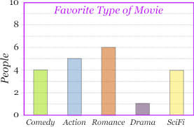

4 people like comedy; 5 people like action; 6 people like romance; 2 people like drama; 4 people like Sci-Fi

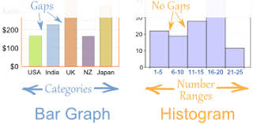
Shows Ranges(groups)
Examples
1 to 5; 6 to 10; 11 to 15; 16 to 20; 21 to 25

