Box Plot:
Ranks data
Shows median (Q2): The point or line inside the box
Shows median of lower quartile (Q1 or lower quartile): The first point or line of the box
Shows median of upper quartile (Q3 or upper quartile): The third point or line of the box
Box part is made up by (Q1, Q2, Q3)
Plots the minimum and maximum values or lowest and highest values called whiskers
Uses five points above number line to create box-and-whisker plot

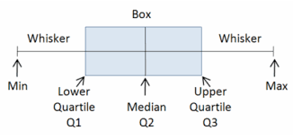

Example:
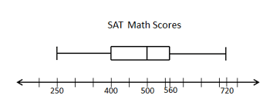
Minimum: 250 Quartile 1: 400 Quartile2: 500 Quartile 3: 560 Maximum: 720
Lowest number median highest number

Range: highest number minus lowest number (720 – 250) = 470
Inter Quartile Range (IQR): Q3 minus Q1 (560 – 400) = 160
Mode and Mean usually are not able to find in a box plot

