Circle Graph or pie chart
Helps visualize data
20 people were surveyed on the favorite type of movie.
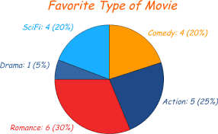
Results:
SciFi: 4/20
Comedy: 4/20
Drama: 1/20
Romance: 6/20
Action: 5/25
Steps to get a Percent
Change Fraction to decimal 1 divided by 20 = 0.05 (drama)
Change Decimal to percent 0.05 x 100 = 5% (drama)
Steps to change a percent to degrees
5 divided by 100 = 0.05 (drama)
.05 x 360 ⁰ = 18⁰ (drama measures 18⁰ of the circle graph)
Or you can try to visualize how many degrees make up a section of a circle. A circle =360⁰.
