Coordinate Plane
Has 4 quadrants made up by the intersections of the x-axis and y-axis.
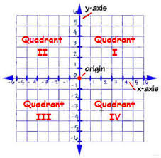
Example
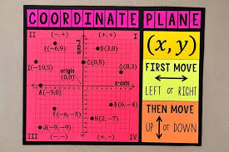
Ordered pair(x, y) gives directions to follow so you are able to plot points.
Always begin at the origin. X tells you to go across. Y tells you to go up or down
If first number is positive move __ units right. Then move __ units up if second number is positive.
If first number is negative move __ units left. Then move __ units down if second number is negative.
(5, 4)
x-coordinate y-coordinate

