Scatter Plot:
Data plotted to try and show an association (relation) between two quantities (variables).
Types of Scatter Plot Associations (correlations):
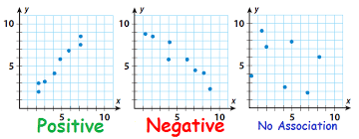
y-values increase as y-values decrease no pattern between
x-value increase as x-values increase x and y values
Linear Linear
Trend Line (best fit line) are used to make predictions inside the data and outside the data.
Straight line drawn though the data points which usually shows a positive or negative correlation.
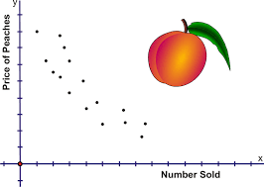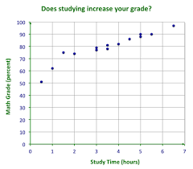
As the price decreased the number of As the study hours increased the math grade
peaches increased. increased.
For every $1 decreased peaches increase by 1 For every 1 hour studied grade increases 10 points
Association (negative) (positive)
Outlier: a point that is off from the other data points
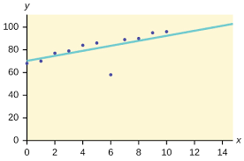 Outlier: (6,60) for 6 hours I only made $60 (should be $78)
Linear: data appears to make straight line Non-Linear: not a straight line; has a curve

