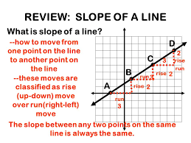 slope of the line = 2/3
Slope: steepness of a line, unit rate, rate of change, rise/run (y/x)
The steeper the line the greater the slope.
To Compare Proportional Relationships
Find the slope (rate) for each relationship to compare.
Tom
hours | pages
2 | 60
5 | 150
7 | 210
12 | 360
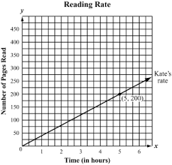
200 ÷ 5 = 40 150 ÷ 5 = 30
Kate reads 40 pages/hour Tom reads 30 pages/hour
Kate is reads 10 more pages than Tom every hour.
You can also find the changes of y to find the slope.
changes of x

200 – 0 = 40
5-0
