Solving System of Equations by Graphing (Linear Equations)
If you were to graph two equations these would be possible solutions of a system of equations.
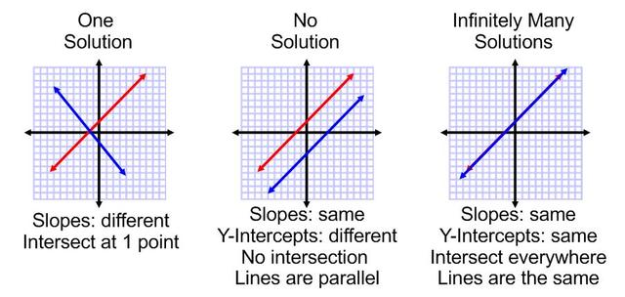

Explanation for one solution:
Coordinates of a point would satisfy the equation of the line if the point is on the line.
If the point satisfies the equation of two lines, the point is on both lines, therefore the lines intersect at that point.
This means that the point where the two lines intersect is a solution to the system of equations.
This means that if you substitute x and y values of the point for x and y in the equations both equations will be true.

Use equations to determine the slope and y-intercept. (y = mx + b)
m = slope; b = y-intercept
Example
y = 2x + 5
slope = 2 y-intercept = 5
Steepness y-intercept tells you where the line touches the y-axis
Unit rate
Rate of chance
Slope gives you directions: two units up (rise) and 1 unit to the right(run)

